Patrick Austin

CS 450 Lab 1

9/13/2017

1.

a. The dictionary attack solved 11 passwords.

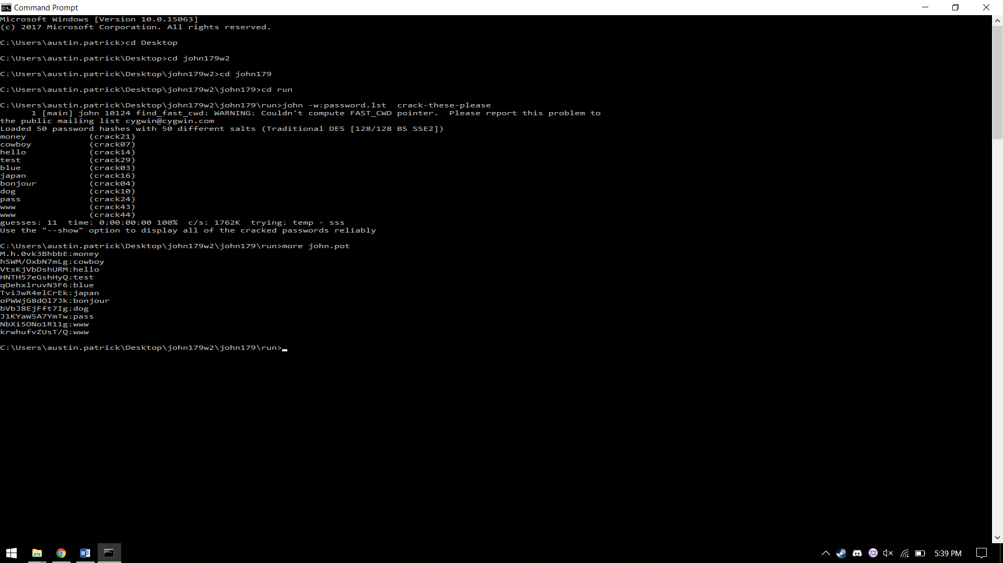

b. The hybrid attack solved 1 additional password, for a total of 12.

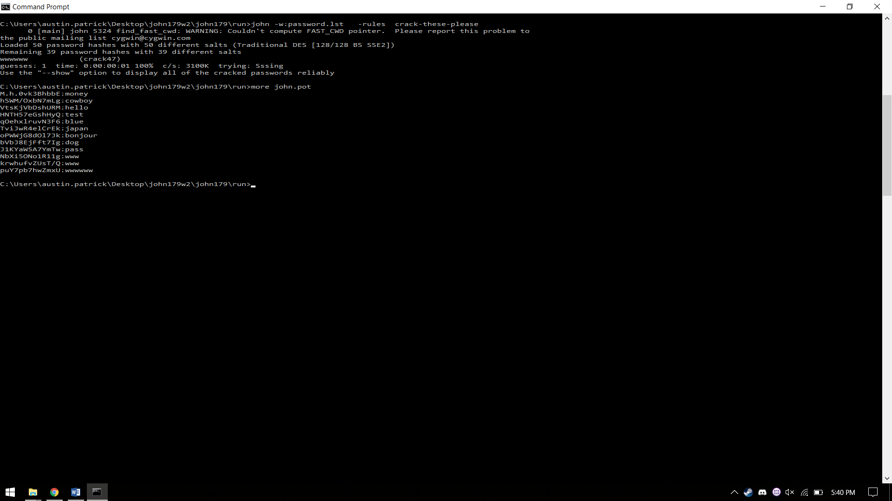

c. The combination attack solved 24 additional passwords over 10 minutes of runtime, for a total of 36 passwords.

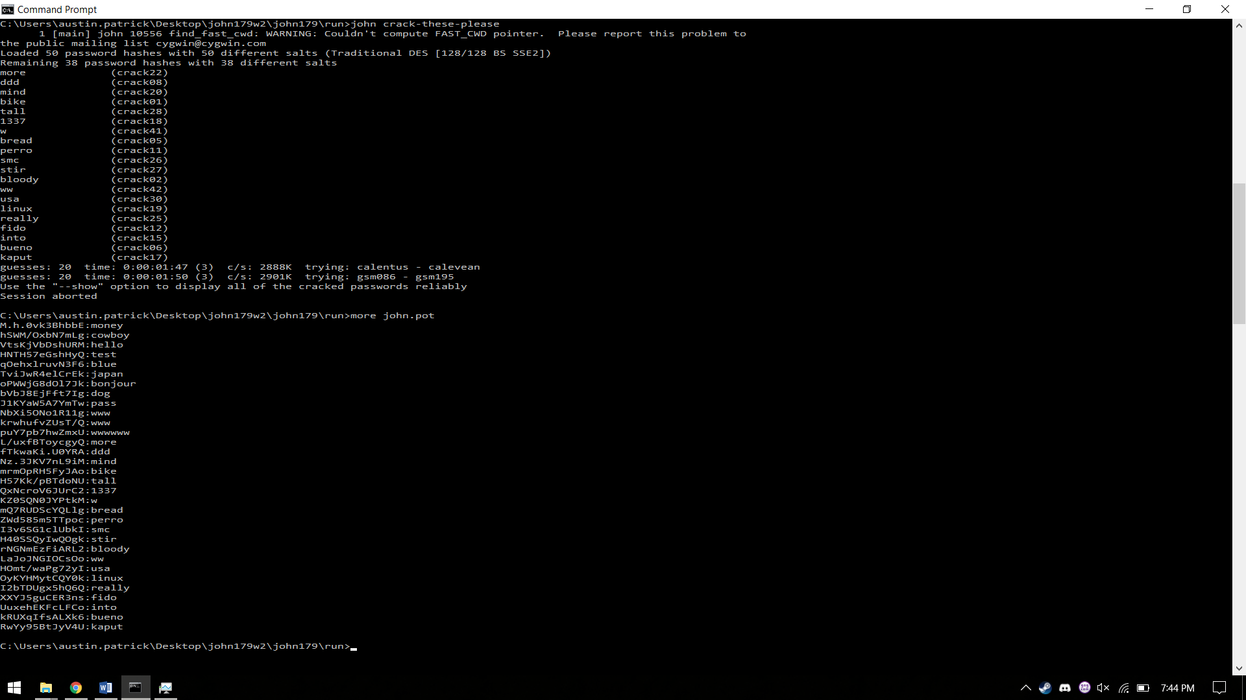

d. 14 of the 50 passwords were never solved, and 36 were solved.

2. In Windows, the password hashes are stored in Windows\System32\config and in HKEY_LOCAL_MACHINES\SAM in the registry. However, these locations are not accessible while Windows is booted.

3.

a. 50 years is 438,000 hours. A password that takes at least that long to crack and contains only numbers must have 17 digits.

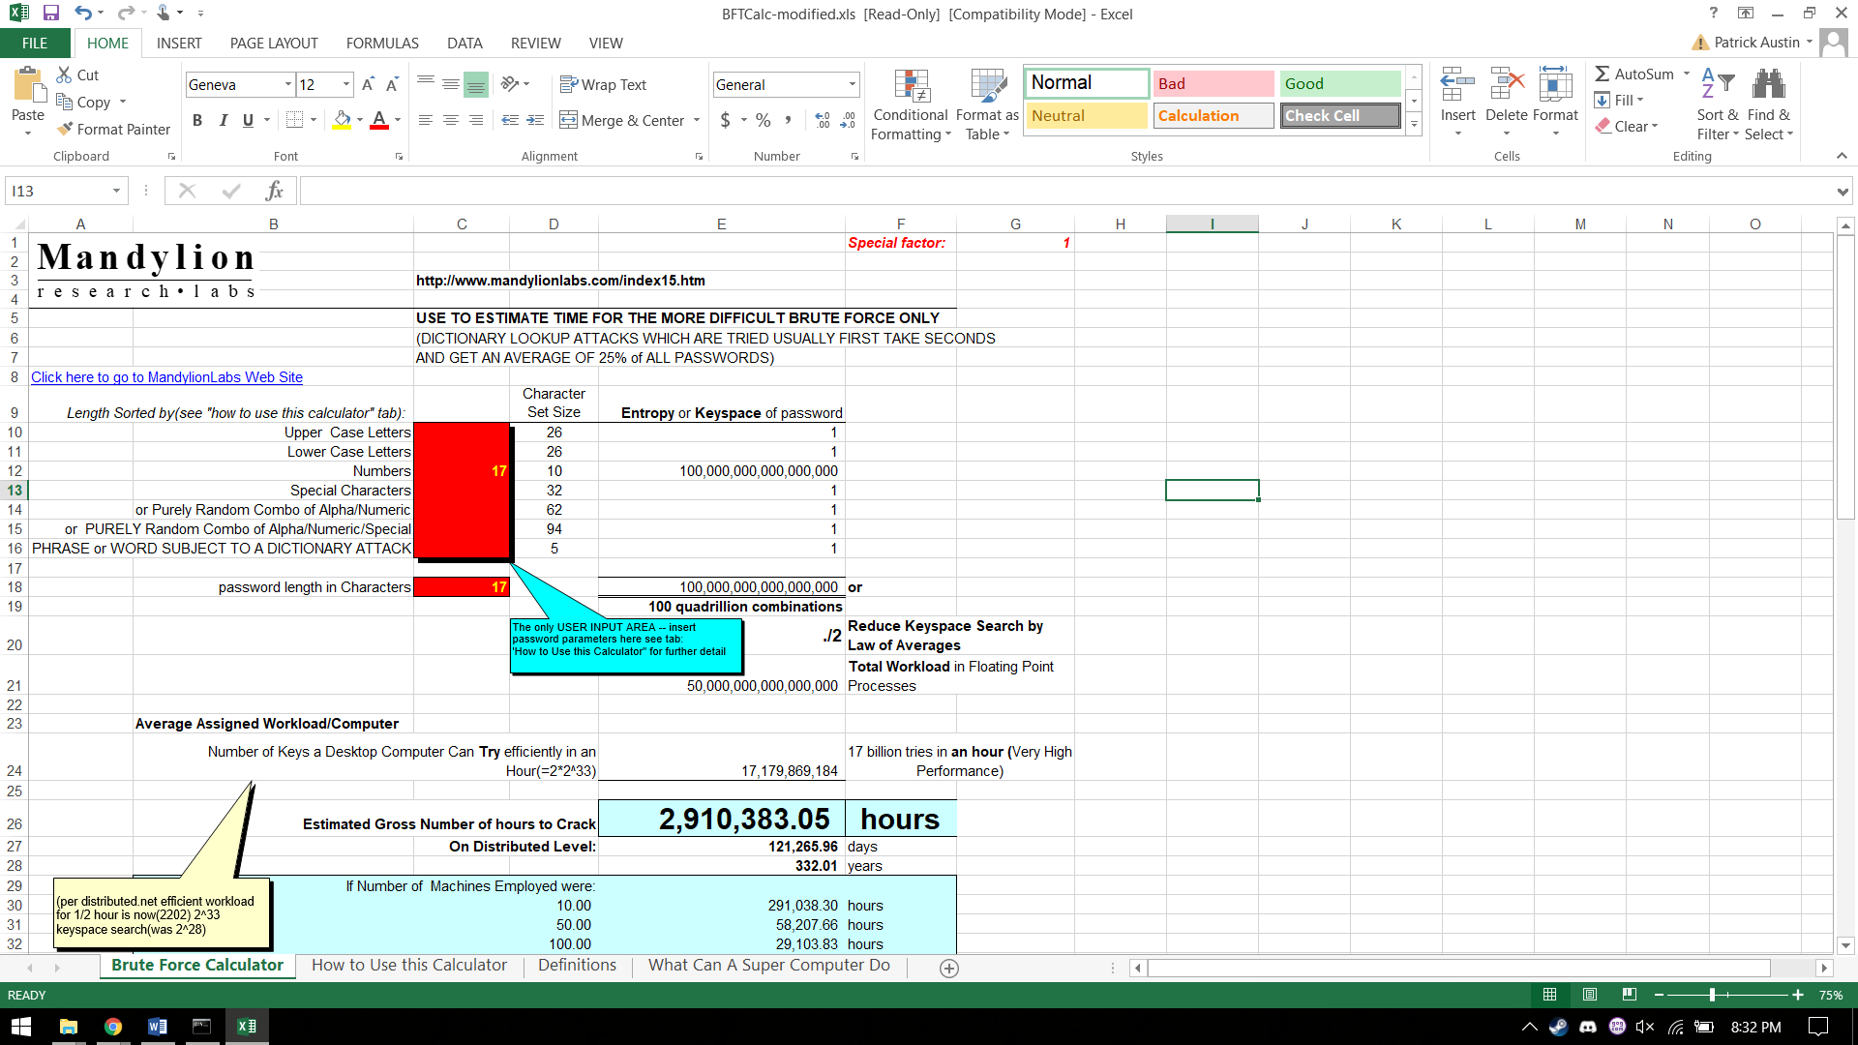

b. After accounting for Moore’s law, the password requires 18 digits in order to take more than 50 years to crack.

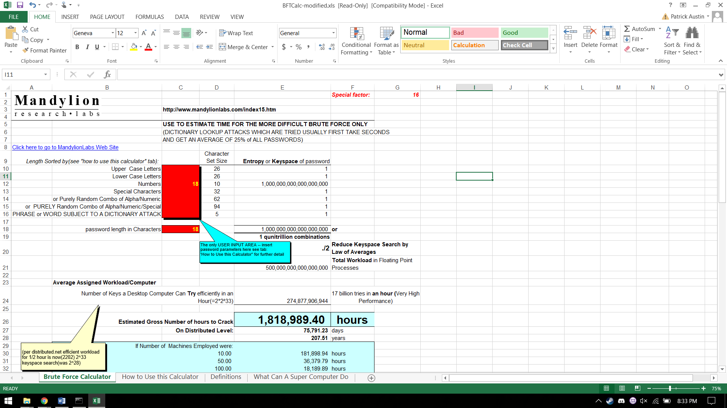

c. After accounting for Moore’s law’s continued operation, the password requires 24 digits in order to take more than 50 years to crack.

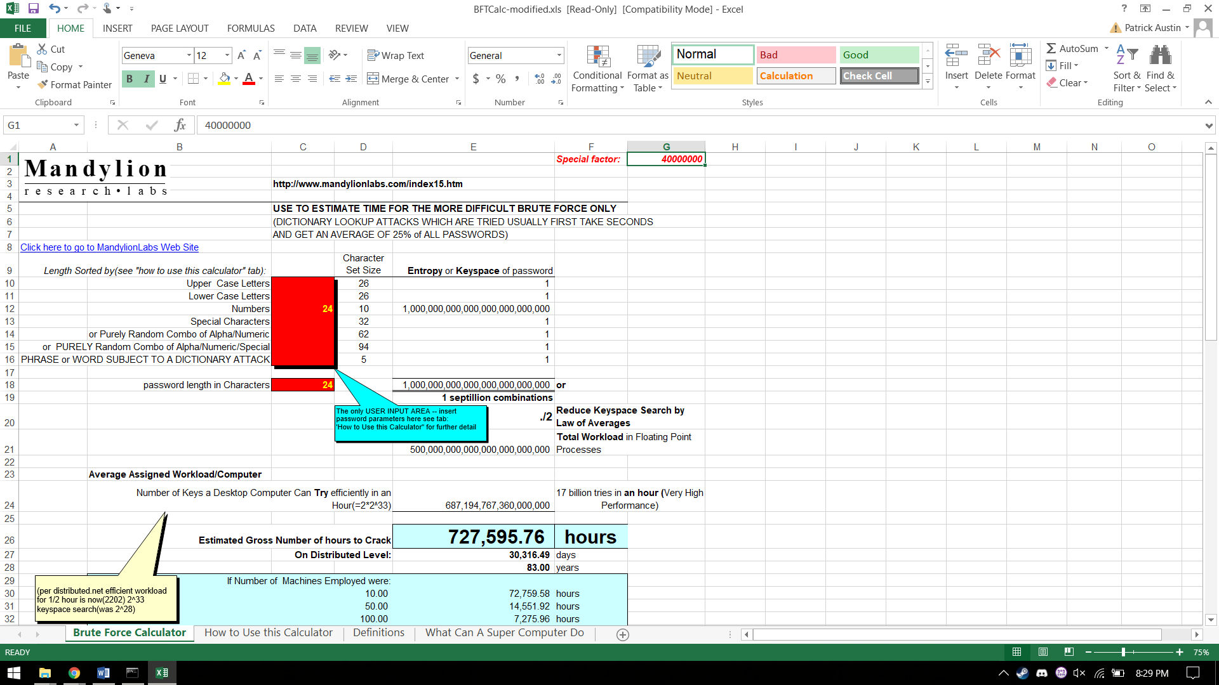

d. If mixed characters are used and the Moore’s law assumptions are the same as in part c., then only 13 characters are needed.

